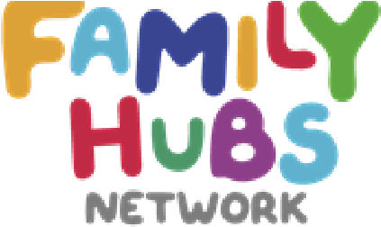
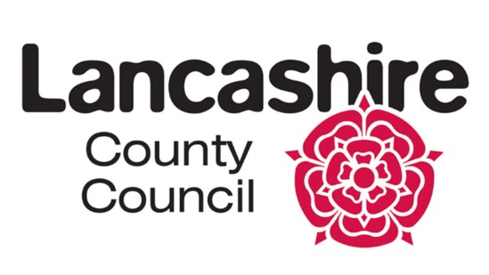
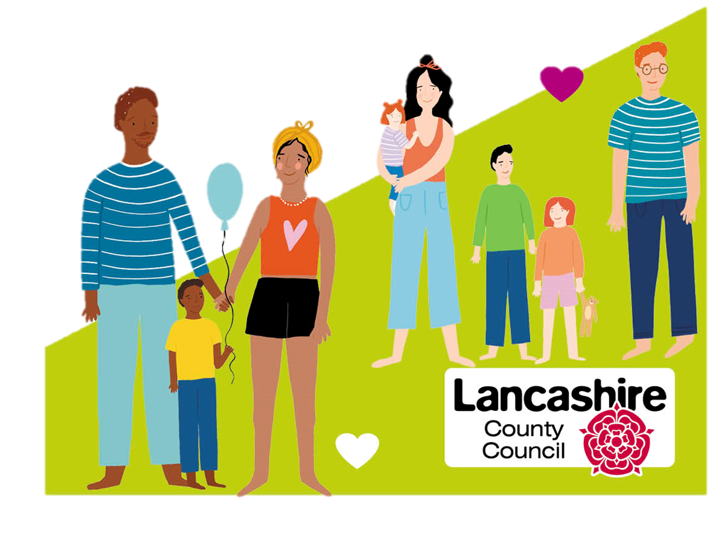

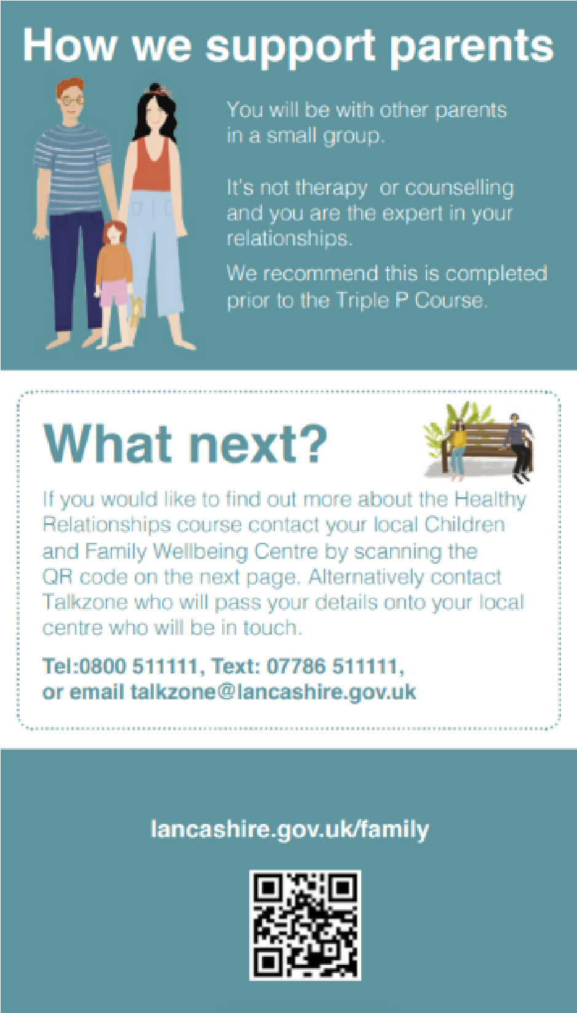




W
E
L
C
O
M
E

T
O

All families have arguments, it is part of how we negotiate, make decisions, understand each other and live together. This is constructive communication which children learn from seeing how arguments are resolved. However, when arguments become frequent, intense and poorly resolved it is destructive communication and children suffer from being exposed to it. There is support on hand and we would encourage you to come along and give this course a go if you find yourself entrenched in ongoing destructive conflict with your co-parent.
The course runs for 4 weeks and aims to work in a solution focused way, enabling and empowering you to understand your conflict. You will learn to resolve the issues yourselves rather than relying on a practitioner for solutions.

POSITIVE

RELATIONSHIPS

Here to support with
family relationships
and emotional health
The sessions will cover:

- The effects of conflict on children, co-parents and the causes of conflict within a relationship

- The stages of relationship development, how our existing vulnerabilities can make us more susceptible to conflict

- Understanding that we bring different perspectives to our relationships

- Constructive and destructive communication

- Understanding emotions, thoughts, feelings & behaviours

- Better communication, understanding expectations & reality

- Goal setting

HOW CAN WE
HELP YOU
STRONGER
FAMILIES
We can support anyone who has a significant caring responsibility for a child, including individuals who are:
In a relationship

Separated or divorced

Biological or step-parents

Foster or adoptive parents
Same sex parents
WHO IS IT FOR?
GET IN TOUCH
WEBSITE:
DISTRICT SOCIAL MEDIA
Facebook Page:
Burnley Family Hub
Hyndburn Family Hub
Pendle Family Hub
Rossendale Family Hub
Ribble Valley Family Hub

If you would like to find out more about the Positive Relationships course, contact your local Family Hub by scanning the QR code. Alternatively contact the Reducing Parental Conflict Team or Talkzone.
Talkzone Tel: 0800 511111 Text: 07786 511111
Email: talkzone@lancashire.gov.uk
CFW-RPCleads@lancashire.gov.uk

LANCASHIRE COUNTY COUNCIL EVENTS
Ribble Valley Family Hub

