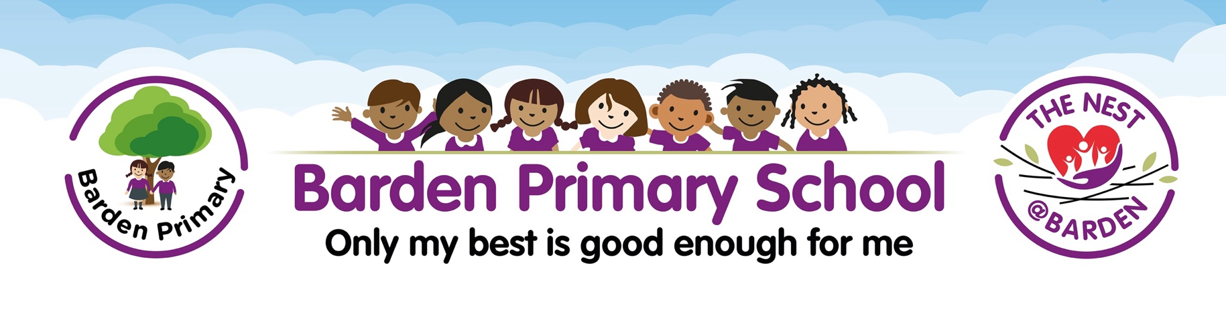

29th November 2024
IMPORTANT LETTER REGARDING BUILDING WORK

Dear Parents/Carers,

I hope this letter finds you well. I am writing to inform you of some important building works that are taking place at Barden Primary School on Burnley Campus.
As part of the ongoing improvements and maintenance across a number of Lancashire schools, the county council has undertaken surveys at schools constructed under the Government's Building Schools for the Future Programme. During these inspections, surveyors have identified some areas that require further investigation to ensure the continued safety and integrity of the building.
To allow these investigations to take place and to ensure the safety of our children, staff, and visitors, fencing is currently being erected around specific areas of the school. This will remain in place until a thorough inspection has been completed and any necessary repairs have been carried out.
We want to reassure you that the county council is doing everything possible to ensure this work is completed quickly and with minimal disruption to the school day. Health and safety remains our top priority throughout this process, and we are committed to maintaining a safe learning environment for all.
We will continue to keep you updated on any developments and appreciate your understanding and co-operation during this time. If you have any questions or concerns, please do not hesitate to get in touch with me or catch me on the playground before school.
Thank you for your continued support.
Kind Regards,
Mrs C Holgate
Headteacher
Barden Primary School

