


This template can be used for multiple purposes:
by:
- It enables schools to effectively plan their use of the Primary PE and sport premium
- It helps schools to meet the requirements (as set out in guidance) to publish information on their Primary PE and sport premium
- It will be an effective document to support Ofsted inspections enabling schools to evidence progress in Physical Education (PE) and evidence swimming attainment, which forms part of the PE National Curriculum. We would recommend schools consider
the Intent, Implementation and Impact of any spend, as examined within the Education Inspection Framework.

It is important that your grant is used effectively and based on school need.

Schools must use the funding to make additional and sustainable
improvements to the quality of the PE, School Sport and Physical Activity (PESSPA)
they offer. This means that you should use the Primary PE and sport premium to:

- Build capacity and capability within the school to ensure that improvements made now will benefit pupils joining the school in future years
- Develop or add to the PESSPA activities that your school already offers.

The Primary PE and sport premium should not be used to fund capital spend projects; the school’s core budget should fund these. Further detail on capital expenditure can be found in the updated Primary PE and sport premium guidance.

The Primary PE and sport premium guidance, outlines 5 key priorities that funding should be used towards. It is not

necessary that spending has to meet all the key priorities, you should select the priorities that you aim to use any funding towards.

Although completing this template is not a requirement for schools, schools are required to publish details of how they spend this funding. Schools must also outline what the impact this funding has had on pupils’ PE and sport participation and attainment and how any spending will be sustainable in the future. All funding must be spent by 31st July 2024.

The Department for Education has worked closely with the Association for Physical Education (afPE) and the Youth Sport Trust (YST) to develop this template and encourages schools to use it. This template is an effective way of meeting the reporting requirements of the Primary PE and sport premium.

Key performance indicators related to PESSPA

Key indicator 1: the engagement of all pupils in regular physical activity – Chief Medical Officers guidelines recommend that primary school pupils undertake at least 60 minutes of physical activity a day in school. (KI1)

Key indicator 2: The profile of PESSPA being raised across the school as a tool for whole school improvement (KI2)

Key indicator 3: Increased confidence, knowledge and skills of all staff in teaching PE and sport (KI3)

Key indicator 4: Broader experience of a range of sports and activities offered to all pupils (KI4)

Key indicator 5: Increased participation in competitive sport (KI5)

Review of last year’s spend and key achievements (2022/2023)

We recommend you start by reflecting on the impact of current provision and reviewing your previous spend.

Activity/Action | Impact | Comments
Achieved the School Games gold Framework.  The development of playground zones.  Key staff training and CPD revolving around the delivery of the PE curriculum  A wide range of extra-curricular clubs  All children in KS2 were involved in swimming lessons throughout the academic year  We took part in both National Fitness Day and National Sports Week.  We have two members of staff who have attended the middle leadership for healthy schools. | This shows the continued dedication to delivering a range of physical activities for children at Barden to take part in.  This has encouraged our children to engage with different activities during break times, facilitating more independence in the children and developing their core values.  This has led to 78% of children working at an expected level in PE (75% working at the expected level and 3% working above the expected level).  This has led to every child being targeted to be involved in an activity taking place during break time, lunch time or after school. Furthermore, wider ranges of staff were involved in the delivery of the clubs being involved in weekly and termly rotas.  This is helping to increase the development of swimming in our children.  This helped to further promote sports and physical activity at Barden Primary School, with children in both Key stages taking part in a range of activities, including Sports Day – leading to 100% participation.  This has supported the Elevate team when we are creating an active school. This brings new ideas to support the development of the children’s physical, health and mental well-being.

Key priorities and Planning
This planning template will allow schools to accurately plan their spending.

Intent | Action – what are you planning to do | Who does this action impact? | Key indicator to meet | Impacts and how sustainability will be achieved? | Cost linked to the action
Ensure every child has access to at least 60 minutes of activity per day with a particular focus on structured playtime activities  To plan, monitor and assess P.E. using the Lancashire scheme of work through P.E. passport.  To increase the development of in physical literacy of the children through focused CPD and training opportunities  To utilise the SSP buy in to support in a number of key areas of participation and competition.  Focus on offering opportunities of enrichment for the children, allowing them to experience sports/activities outside the normal PE curriculum  To raise the overall profile of sport and physical activity, using the school games framework as a guideline. | Develop our playgrounds arrangements and activities using the OPAL playground approach.  Regularly participate in Go Noodle during the transition from one lesson to another.  To audit the current skills and areas of development of the staff delivering PE at Barden  To monitor the standard of PE through termly walkthroughs.  To provide ECTs and RQTS extra support through team teaching and planning support, through S Darcy (sports specialist).  To assess KS1 in years 1 and 2 against the baseline assessment – to monitor progress being made in the development of FMS  To assess the progress being made by the children on a termly basis  To provide training for all staff creating an engaging playground through OPAL  To provide CPD for staff developing their knowledge in the PE curriculum  Staff that are new to Barden to receive training on the Lancashire schemes of work.  Utilise the SSP to provide CPD for staff in highlighted areas of weakness from the curriculum audit.  Utilise the buy in to participate in inter-school competitions allowing children to participate across a number of different competitions,  Report through class assemblies and blogs on the website.  To utilise the buy in to participate in cluster competitions.  To utilise the SSP buy in to use external coaches for quality extra-curricular clubs.  To access external coaching hours made available through the buy in to provide CPD opportunities for staff.  To provide enrichment opportunities for children who are PP. activities will take place both in school and through different facilitators.  To provide extra-curricular clubs for both KS1 and KS2 children.  To hold intra-competitions in year groups, to assess the end of units in PE – evidence through photos, videos and assessment.  To inform staff and parents of the progress of sports and P.E. on a regular basis, through newsletters.  To utilise the school games tools (inclusive health check) to develop the profile of sport and physical activity | Teachers, Teaching assistants and welfare staff, as they will be leading the activities in the classroom and on the playground.  The children who will be taking part.  The staff in the classroom who will be facilitating participation in Go Noodle.  The children who will be taking part.  Teachers and HLTAs who deliver PE during curriculum time.  Teachers, HlTAs and Teaching assistants involved in delivering PE.  PE subject leads who will be monitoring.  Sports lead – Sarah Darcy who will support with coaching.  New to Barden – CC and DB  KS1 teachers.  Teachers planning, teaching and assessing PE.  External provider (OPAL)  Teaching staff  Welfare staff  KS1 and KS2 children  PE subject lead and sport lead  External providers (SSCO / external community club)  Teaching staff  CC and DB to attend training for Lancashire PE scheme of work for KS2  Teachers who have areas in the curriculum that require development  Children participating in the different levels of competition provided.  Staff who chaperone the children to the events so they can participate.  Children in both KS1 and KS2  Staff who chaperone the children to the events to participate.  External coaches from local community sports clubs.  Children from KS1 and KS2  Sports lead and PE subject lead.  External providers  External coaches  Children on the pupil premium register in both KS1 and KS2  Sports lead  Teaching assistants supporting  Teaching staff who lead and support clubs.  Sports lead and PE subject lead.  KS1 and KS2 children involved in lunchtime and afterschool clubs.  Teaching staff delivering the PE curriculum  Sports lead and PE subject lead  Children in KS1 and KS2  Sports lead and PE subject lead  Sports crew members  Parents  Sports lead and PE subject lead  PE subject lead and sports lead | KI1, KI2, KI4  KI1  KI3  KI3  KI3  KI3  KI3  KI1, KI2, KI3, KI4  KI3  KI3  KI3  KI2, KI4, KI5  KI2, KI4, KI5  KI2, KI4, KI5  KI2, KI4  KI1, KI2, KI4, KI5  KI2, KI4, KI5  KI1, KI2, KI5  KI2, KI4, KI5.  KI1, KI2 KI4 | More children will meet their daily goals of achieving 60 minutes of exercise a day. Children will develop more independence in participating in recreational play and sporting activities.  More children will meet their 60 minutes of activity a day. Children will be provided with small breaks from their learning to help re-engage in their learning.  Staff that have areas in need of development will be provided either CPD, planning support or team teaching. This will help to develop their area of weakness.  Walkthroughs will indicate whether PE is delivered to a consistent standard across the key stages. Through feedback, teachers will be able to improve their practice.  Teachers will be provided support with using PE Passport to deliver the Lancashire PE scheme of work. After team teaching, staff will be more confident delivering PE without support.  To assess the development of fundamental movement skills in PE. Children will be provided with opportunity to develop more ‘mature’ movement skills through tailored planning. Children identified with immature movement skills will be targeted in class, provided with further support using the STEP process.  Through assessment, it will be clear to see the children who need further support to be working the expected level.  Training will provide staff with the knowledge of how to provide the children with the best opportunities for taking part in activities revolving around play. This will develop the level of participation in physical activity and help to develop key life skills.  Teachers will be provided with a wider understanding of the curriculum. This will mean children will have greater opportunities for skill acquisition during PE.  Teachers will have a greater understanding of how to deliver the PE curriculum at Barden. They will be able to facilitate the learning for children in PE.  Staff will be provided with the support required to develop. The staff will feel more competent in delivering all area of the PE curriculum.  Children will be provided with the opportunity to represent the school in a sporting sense. There will be an increase in the desire to represent the school  To increase the opportunity of participation in sports and physical activity for children in KS1 and KS2. This will lead to more children wanting to be involved in physical activity at Barden.  Children in KS1 and KS2 will be provided with quality extra-curricular and curriculum time sessions related to different sports. Children will be learn sports specific skills related to their chosen sports. Furthermore, we will strengthen existing links with community clubs to provide pathways for children that show a greater interest in wanting to carry on participating away from a school setting.  This will enhance the sustainability of quality teaching from the current cohort of staff.  Children will be provided with an opportunity to engage in activities they would not be able to. The children will develop an interest and liking for a wider range of physical activity, increasing the overall participation levels.  Children will be able to participate in a range of clubs throughout the academic year, exposing them to a broader range of activities. Children will be able to develop their physical literacy in a competitive and recreational manner.  Children will be able to apply their learning from curriculum into competitive situations against their opposite class. Children will develop experience of participating in more competitive situations.  The achievements of the children will be celebrated in our weekly assemblies and through pictures and blogs on the school website. This will help to further engage parents and encourage children to want to participate in sports at Barden.  This will help to raise the awareness of how many opportunities there are for physical activity at Barden. It will enable us to see where we can increase opportunities for physical activity in the school day. | Cost of Opal play £5000  Resources for the playground £600  No cost.  Potential cost of CPD £100 PP  Potential cost of subject leader being covered in the classroom £200  No cost.  No cost.  No cost  Training provided through OPAL buy in.  Training provided through buy in to SSP.  £200 for training  £5,600 for the buy in towards the school the school sports partnership. .  Provided through buy in towards SSP.  Provided through buy in towards SSP.  Provided through buy in towards SSP.  Provided through the buy in to the SSP.  £1000 for external providers  £1000 for transport to and from providers  No cost.  No cost.  No cost.  No cost.

Key achievements 2023-2024
This template will be completed at the end of the academic year and will showcase the key achievements schools have made with their Primary PE and sport premium spending.

Autumn Term
Activity/Action | Impact | Comments
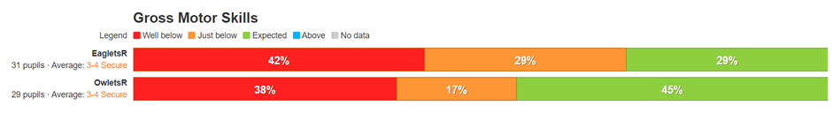  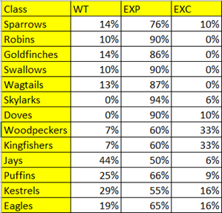  Staff audits were conducted at the beginning of the Autumn term to determine the confidence in planning, differentiation, teaching of skills and progression in learning for each unit being delivered.  Classes regularly take part in Go Noodle during the school day. Teachers have their choice when they stop for Go Noodle.  Support for ECTS has been provided through team teaching and regular support in PE lessons from sport specialist S. Darcy. Both ECT’s and teachers new to Barden are provided with support delivering the PE curriculum.  We have utilised the buy in to the SSP to upskill our staff, targeting CPD for different units being delivered in PE. Staff that have received CPD:  - CC- KS2 Gymnastics  - DB - KS2 Dance  - TA - Healthy Movers  - DW - Gymnastics refresher  - AL – KS2 SOW training  - SD – Primary Tennis course  Through the buy-in to the SSP, we have been able to compete in inter-competitions. Competitions attended in Autumn Term:  - Tag rugby practice - 8 children year 5&6  - OAA (SEND) - 6 children year 4  - Active 60 minutes - 10 children year 3&4  - Tag rugby competition - 8 children year 5&6  - Bowling (SEND) - 5 children year 2-4  - Cluster event (bench ball) - 8 children year 5&6  - Multi skills event (SEND) - 8 children year 3&4  - Gymnastics event - 6 children year 3&4  - Santa dash - 8 children year 3&4  Competitions through Spring Term:  - Bench ball cluster event – 6 children year 6  - KS2 Penathlon – 6 children KS2  - Speed stacking – 6 children year 4  - Athletics – 12 children year 5&6  - Athletics – 8 children year 3  - Girls Football – 10 children year 2&3  - Active 60 minutes – 10 children Year 5&6  - OAA – 8 children year 3&4  - Girls football – 8 girls year 3&4  - Cross country – 8 children year 5&6  - Rugby skills festival – 8 children year 3&4  Through the buy in to the SSP, we have had access to external coaches for CPD. Below are the coaches that have delivered CPD so far:  Burnley Rugby Club - CPD for AR and JC  Sanderson’s Dance - CPD for AR  Burnley Leisure – skills to play – SH  Burnley Leisure – Netball – SD  Healthy minds – AR  Lancashire Cricket – AL, DB, BB and JC  Enrichment clubs have been running on a weekly basis during Autumn2, with Pupil Premium children in KS1 and EYFS going to Giddy Kippers.  External clubs for enrichment for children:  - Burnley Leisure - Handball club afterschool club  - Burnley Leisure – Cricket club afterschool  - Burnley Leisure – Netball club afterschool  Afterschool clubs delivered in the Autumn term:  - Year 1&2 dodgeball - 15 children  - Year 3&4 dodgeball - 17 children  - Year 5&6 football - 28 children  - Year 5&6 tag rugby - 9 children  - Year 5&6 handball - 14 children  Afterschool clubs delivered in the Spring Term:  - Year 5&6 Athletics – 14 children  - Year 3&4 cricket – 10 children  - Year 5&6 netball – 10 children  Through walkthroughs conducted during Autumn 2, we were able to see a range of sessions being delivered. Of the teaching observed, the PE was consistently good across EYFS, KS1 and KS2. There was clear progression in the lessons and children had a good understanding of the objective they were working on. The skills for the units were being correctly demonstrated, taught and corrected if there were any misconceptions in learning. Group sizes were appropriate with little waiting time for the children, ensuring every pupil was active for the whole lesson.  Our children who are on the pupil premium register are involved in our enrichment program. This involves providing them with opportunities they would not necessarily experience outside of school. This term has involved trips to Giddy Kippers.  We have facilitated a visit from a sporting superstar, Paul Sturgess. He delivered an assembly and basketball taster sessions for all children in school. | This has provided the PE and sports lead with the perceived key strengths and areas of development of the staff. We have been able to provide CPD and support from the results of the audit.  Children have been provided with an opportunity to have an active break between lessons, enabling the children to have a chance to refocus on their learning.  Through support provided, ECT’s have been given the tools required to plan, deliver and assess PE effectively at Barden. This has been clarified through walkthroughs observing good practice from ECT’s.  The staff have developed their pedagogical understanding of PE and will be able to contribute to a more sustainable delivery of a wide range of units in PE.  Through the offer of extra-curricular clubs within school, children have been provided with an opportunity to take part in physical activity and competitive situations. The children have been provided with an opportunity to develop both physical skills and values related to the different sports they are involved in.  Through quality CPD, staff have been able to develop their pedagogical knowledge, leading to a deeper understanding of how to plan, deliver and assess a wider range of units in PE.  PP children have been able to take part in experiences that will have a life-long impact on them, providing both physical activity and memorable moments  Children have been provided with an opportunity to participate in afterschool and lunch time clubs, giving the opportunity for the children to further develop skills in areas they find interesting. It also helps to shape and develop the children’s characteristics and values, using sport as the tool.  From walkthroughs, we have been able to identify key areas of development we need to target in the school. This has shaped our CPD and team teaching approach going into the Spring term.  PP children have been able to take part in experiences that will have a life-long impact on them, providing both physical activity and memorable moments  The children loved the visit from Paul and it provided the children with a life-long memory. The visit was an inspiration for the children, with many parents commenting on the positive impact it had on their children.
Spring Term  EYFS data  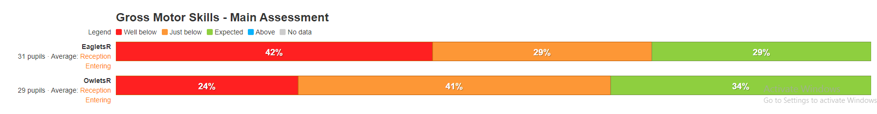  Whole school data  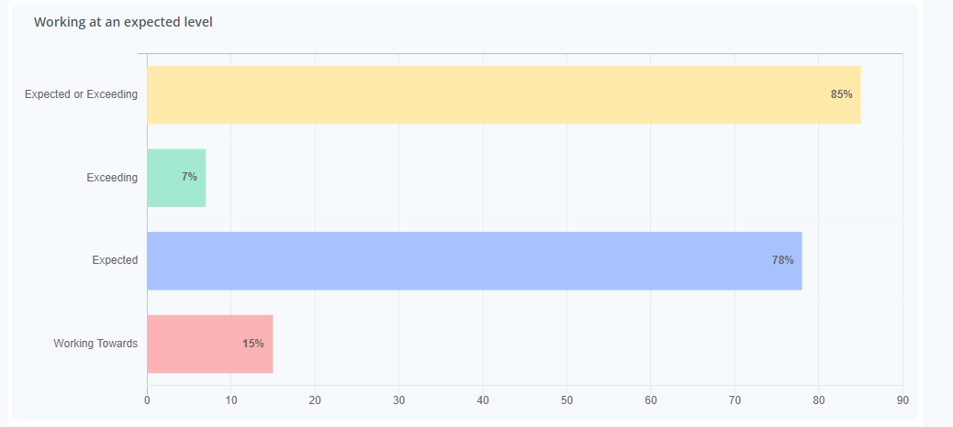  Class data  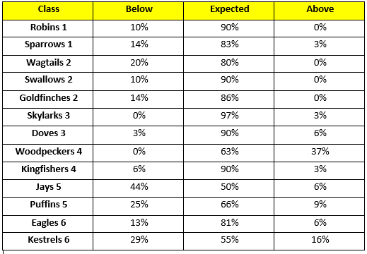  Competitions through Spring Term:  - Bench ball cluster event – 6 children year 6  - KS2 Pentathlon – 6 children KS2  - Speed stacking – 6 children year 4  - Athletics – 12 children year 5&6  - Athletics – 8 children year 3  - Girls Football – 10 children year 2&3  - Active 60 minutes – 10 children Year 5&6  - OAA – 8 children year 3&4  - Girls football – 8 girls year 3&4  - Cross country – 8 children year 5&6  - Rugby skills festival – 8 children year 3&4  During the Spring Term, these are the after school clubs that have been delivered:  - Year 5&6 Athletics – 14 children  - Year 3&4 cricket – 10 children  - Year 5&6 netball – 10 children  A regular enrichment program has carried on from the Autumn term with children going to facilities such as Giddy Kippers. There has also been External clubs for enrichment for children including :  - Burnley Leisure - Handball club afterschool club  - Burnley Leisure – Cricket club afterschool  - Burnley Leisure – Netball club afterschool  Staff have received training on OPAL play regarding the changes that are being made in both KS2 yard to facilitate play for the children. This included having an awareness of the shared vision of the Elevate team, knowing what resources we want and already have and developing a better understanding of how to facilitate play for all children.  More staff have received CPD in a number of areas related to the delivery of PE at Barden. These include:  - Burnley Leisure – skills to play – SH  - Burnley Leisure – Netball – SD  - Healthy minds – AR  - Lancashire Cricket – AL, DB, BB and JC  Summer term  Extra-curricular clubs for summer –  Cricket – Year 5 and 6 – 32 children  Dance – Year 2 – 14 children  Athletics – Year 2 – 21 children  Times table club- Year 4 – 21 children  Gardening club – Year 2 – 12 children  Golf club – Year 5 and 6 – 15 children  Creativity club – Year 3 – 9 children  Art club – Year 2 children – 12 children  Dodgeball club – Year 5/6 – 30 children  Rounders club – Years 5/6 – 9 children  Summer term competitions;  - Spar Lancashire games - 8 children  - Active 60 minutes - 6 children  - Cricket - 8 children  - Girls cricket - 8 children  - High 5 - 8 children  - Quad kids yr 3&4 - 8 children  - Quad kids yr 5&6 - 8 children  Percentage of pupil premium and none pupil premium children attending clubs  - Year 1 –– Pupil Premium 7/16 43% none Pupil Premium 57%  - Year 2 –– Pupil Premium 30% none Pupil Premium -70%  - Year 3 –– 20 Pupil Premium 49 % none Pupil Premium 51%  - Year 4 –– 40 % Pupil Premium 60 % none Pupil Premium  - Year 5 –– 47 % Pupil Premium 53% none Pupil Premium  - Year 6 –40% Pupil Premium 60 % none Pupil Premium  Year 5 girls – 33 girls in total 22 of them in a club = 67%  - Boys 32 24 of them at a club – 73%  Year 6 girls – 41 in total – 28 attended a club – 68%  - 21 boys – 19 attended – 90 %  - Year 1 – (13) 25% SEND attended clubs  - Year 2 – (11) 64% SEND attended clubs  - Year 3 – (11) 45% SEND attended clubs  - Year 4 – (9) 89% SEND attended clubs  - Year 5 – (9) 78% SEND attended clubs  - Year 6 – (12) 92% SEND attended clubs  Enrichment programme for the children who are on the Pupil Premium register  Autumn term –  The Nest – Giddy Kippers  EYFS - - Giddy Kippers  Year 1 – Giddy Kippers  Year 2 – Giddy Kippers  Year 3 – Giddy Kippers  Spring Term -  Year 2 – Giddy Kippers  Year 3 – Giddy Kippers  Year 4 – Laser Fazer  Year 5 – Laser Fazer  Summer Term -  Year 5 – Laser Fazer  Year 6 – laser Fazer  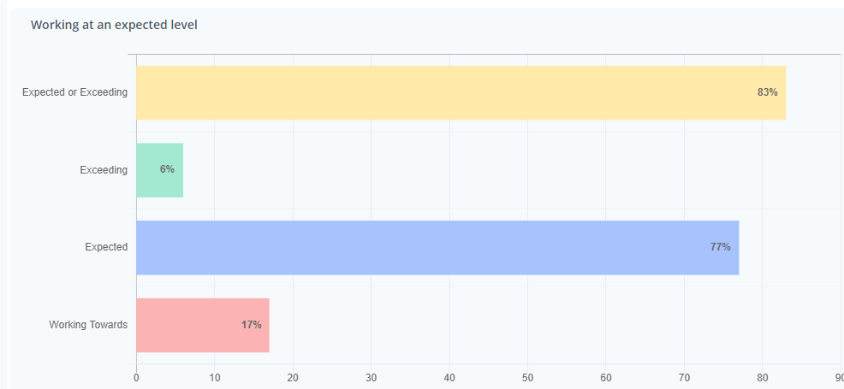  Walkthroughs have been completed during the summer term.  Pupil voice was conducted during the summer term  A deep dive into PE was conducted during the summer term  OPAL play has been implemented in both the KS1 and KS2 playgrounds.  Support for ECTS has been provided through team teaching and regular support in PE lessons from sport specialist S. Darcy. Both ECT’s and teachers new to Barden are provided with support delivering the PE curriculum. | The overall amount of children working at an expected or exceeding level is 85%. This is split into 78% of children working at an expected level and 7% of children working above the expected level. We have maintained a high level of children working at or above the expected level in PE. This is indicative of the teachers levels of confidence assessing their children across different units of work in PE.  From the data recorded in each class, there is a high level of children working at or above the expected level in most of the year groups. However, there are a large number of year groups that have a lower level of children working above the expected level (with exception of Woodpeckers and Kestrels). This highlights the need for targeting children who could potentially work above the expected level.  For the children working below the expected level, differentiation is visible through walkthroughs and there is clear progression being made. More support will be provided, through team teaching and planning support for the year groups with higher levels of children working below the expected level.  Through the offer of extra-curricular clubs within school, children have been provided with an opportunity to take part in physical activity and competitive situations. The children have been provided with an opportunity to develop both physical skills and values related to the different sports they are involved in.  Children have been provided with an opportunity to participate in afterschool and lunch time clubs, giving the opportunity for the children to further develop skills in areas they find interesting. It also helps to shape and develop the children’s characteristics and values, using sport as the tool.  PP children have been able to take part in experiences that will have a life-long impact on them, providing both physical activity and memorable moments. Having the external coaches provide after school clubs has enabled staff to further their own CPD and has also provided the children with a wider offer in terms of sports and activities provided by Barden.  Staff have received a fundamental understanding of the process of developing the playground space at Barden. Staff have a good understanding about the structure and offer the children receive both at playtime and lunchtime. In terms of the children, they have a wider range of activities thy can access at break times. This has been done to facilitate the children s ability to select how they engage and play – leading to more independent values and skills being developed in the school day.  The staff that have received CPD will have the opportunity to utilize the knowledge developed through the forthcoming units of work and extra-curricular offer. The CPD provided has been essential in providing a sustainable delivery of PE at Barden, helping to upskill our staff. This will be observed through walkthroughs during the Spring 2 term.  The children have been able to participate in a number of different clubs that offer the children a chance to apply their learning from PE and experience a different sport. Moreover, the children have been provided with a wide offer of after school clubs to attend, as well as the afternoon clubs that run alongside our OPAL play led break times.  The children have had the opportunity to represent the school in different formats of competition. The children have stated their pride at representing the school throughout the year. This has helped to further develop the values being taught through PE.  Through our extra-curricular offer, we have been able to ensure our offer extends to children who are on the pupil premium register and those who are not. This means we have been able to offer all of our children the opportunity to attend clubs and further their experiences whilst they are with us at Barden.  We have ensured our extra-curricular offer has extended to both boys and girls, with girls in Year 5 and 6 showing positive levels of participation. This shows the wide offer we have for the children at Barden, ensuring all children can be included in groups. This has also gone to show we have ensured we are inclusive in the offer of clubs at Barden, allowing the children to participate in different sporting activities.  We ensure our extra-curricular offer extends to our SEND children. The impact of this has been the inclusivity of our clubs. We ensure all children are provided with the opportunity to attend clubs.  Through our enrichment programme, we are able to provide children who are on the pupil premium register with the opportunity to take part in experiences they would not normally be able to. The impact has been a positive one, with children commenting on how much they enjoy the activities, being able to engage with new experiences.  From the assessment, it is clear to see that we have a high number of children who are working at the expected level. However, the amount of children working above the expected level is nit high. From this, we will look at spotlighting children who are working at an expected level that could be targeted to work above the expected level. As well as this, the 20% of children who have been identified as working below the expected standard will be targeted through small group work and interventions in the autumn term.  From theses deep dives we have been able to observe a consistent delivery of PE across the key stages. Teachers were correctly modelling the skills and giving coaching points. With regards to the structure of the sessions, teaching staff were being utilized in the session to provide appropriate support, addressing misconceptions in learning and promoting progress within the lessons. Teachers showed a good understanding of how to deliver the learning objectives, being able to adapt plans to fit the needs of the children by applying the principles of STEP (space, task, equipment and people).  The results of the pupil voice concluded that the children enjoy taking part in their PE sessions. They are able to explain how the skills they are learning can be applied in different sports. Moreover, they were able to explain how skills learnt in previous years are then applied in their current years PE. The children felt like they were being challenged sufficiently during lessons but felt some lessons were “easier” or “more difficult” than others. This means teachers need to ensure they are being careful when they apply the principles of STEP to ensure all children are making progress during lessons.  Through the deep dive into PE, it was clear that we PE was a robust subject at Barden, with a clear triangulation of evidence to support the implementation of the PE curriculum. Teachers showed a good understanding of how to deliver the PE curriculum, in terms of planning and the assessment of the units they teach in their respective year groups. The standard of teaching is consistent with the approach to PE at Barden. As well as this, pupils were able to articulate how their knowledge in PE has progressed through the different year groups. This shows that PE is a subject at Barden that has been well implemented and consistently run throughout all year groups.  The structure of the playgrounds with equipment for the children to access has been positive. The children have enjoyed the changes that have been applied and have positively commented about it when we conducted pupil interviews in the summer term.  Through support provided, ECT’s have been given the tools required to plan, deliver and assess PE effectively at Barden. This has been clarified through walkthroughs observing good practice from ECT’s.

Swimming Data
Meeting National Curriculum requirements for swimming and water safety.
Priority should always be given to ensuring that pupils can perform safe self-rescue even if they do not fully meet the first two requirements of the National Curriculum programme of study

Question  Current y6 but y5 data. Currently swimming in the Summer 2 term | Stats: | Further context  Relative to local challenges
What percentage of your current Year 6 cohort can swim competently, confidently and proficiently over a distance of at least 25 metres? | 11/60 = 18 % | Use this text box to give further context behind the percentage.  e.g., 30% - we are struggling to get pool space due to our local pool closing so we have had to use a much smaller local school pool. We have had to limit the number of pupils attending swimming lessons during one term which means some pupils have attended fewer swimming lessons than others.
What percentage of your current Year 6 cohort can use a range of strokes effectively [for example, front crawl, backstroke, and breaststroke]? | %  22/60 = 37% | Use this text box to give further context behind the percentage.  e.g., Even though your pupils may swim in another year please report on their attainment on leaving primary school at the end of the summer term 2024

What percentage of your current Year 6 cohort are able to perform safe self-rescue in different water-based situations? | 11/60 18% | Use this text box to give further context behind the percentage.
If your schools swimming data is below national expectation, you can choose to use the Primary PE and sport premium to provide additional top-up sessions for those pupils that did not meet National Curriculum  requirements after the completion of core lessons. Have you done this? | Yes/No
Have you provided CPD to improve the knowledge and confidence of staff to be able to teach swimming and water safety? | Yes/No

Signed off by:

Head Teacher: | (Name)
Subject Leader or the individual responsible for the Primary PE and sport premium: | (Name and Job Title)
Governor: | (Name and Role)
Date:

