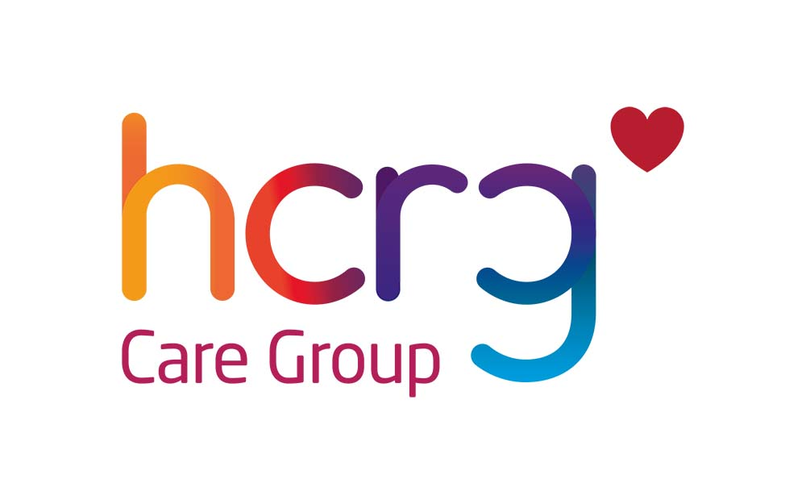
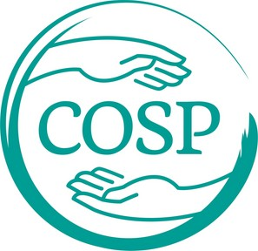
Circle of Security
Parenting

At times all parents feel lost or without a clue about what our child might need from us. Imagine what it might feel like if you were able to make sense of what your child was really asking from you.
The Circle of Security Parenting™ program can help.
What is it?
- An 8 session group programme
- For mums, dads and co-parents of children aged 4 months+ to 6 years
- A relationship based programme.
- Aims to help you make sense of your baby's needs

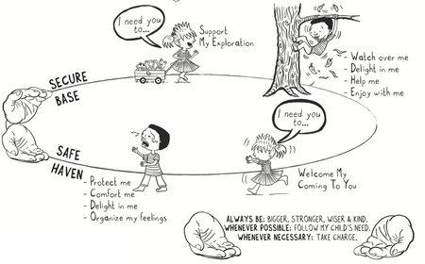
General Information:
- 2 hourly sessions over 8 weeks
- Venues will be arranged across Lancashire
- We hope to be able to provide Creche facilities for children that are not in school or nursery .ossible

How do we sign up for the course?
- Contact your Health Visitor by email to: vcl.019.singlepointofaccess2 @nhs.net
- Call 03002470040 and ask to speak to duty Health Visitors
- We will contact you to advise that we have you referral and discuss available courses
Why will it help?
It will help you to:
- Understand your child’s or baby’s emotional world by learning to read their emotional needs.
- Support your child to manage their emotions.
- Enhance the development of your baby's self-esteem.
- Explore how your experience of being parented affects how you parent.

