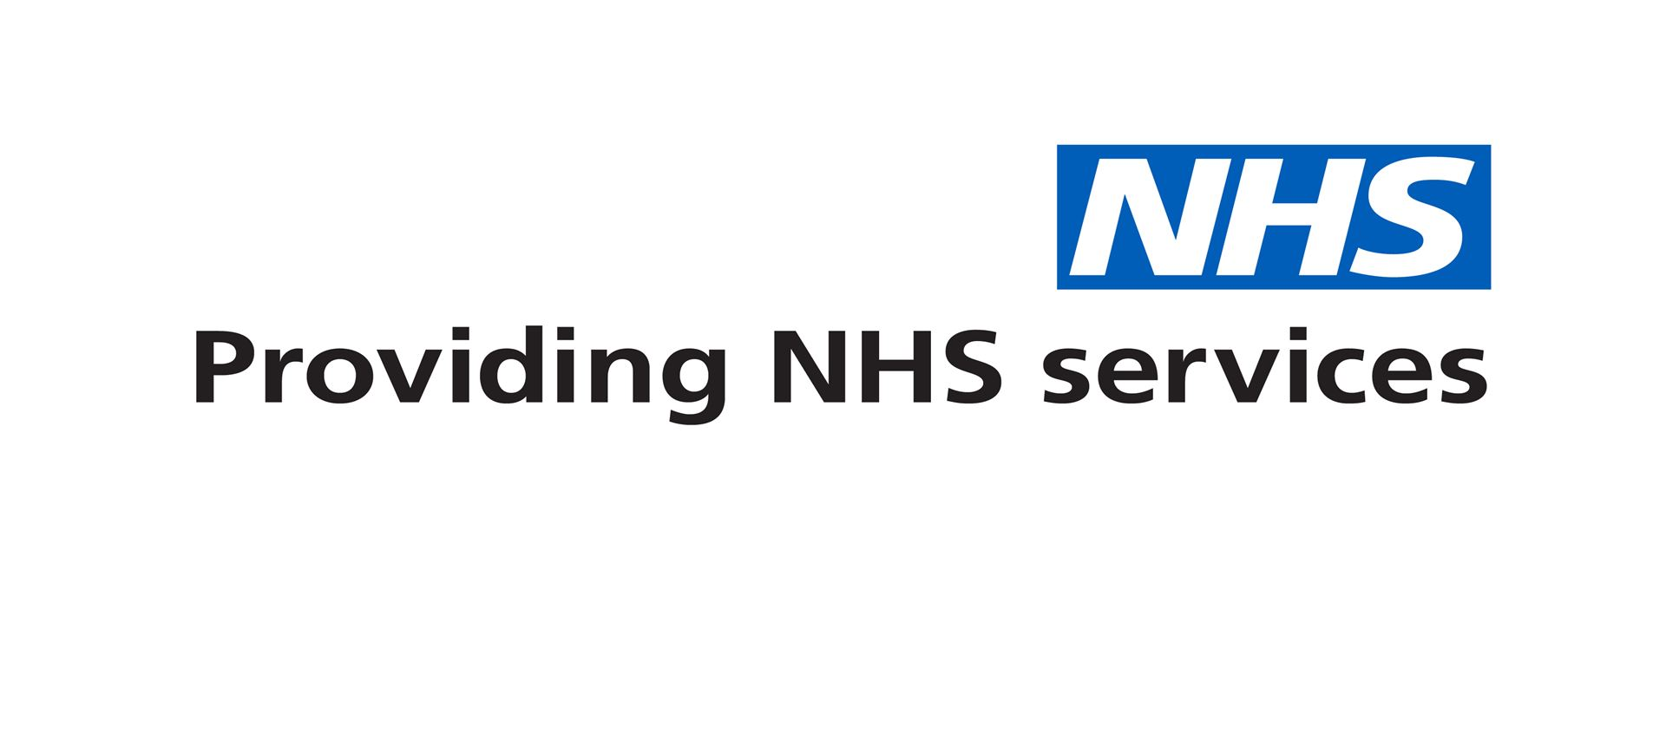
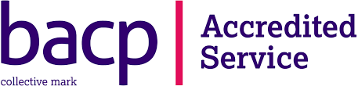

Dear parent/carer,
With the Easter break approaching, at Kooth Digital Health we appreciate there will be some young people who may struggle during the holidays without the access to the daily pastoral support, teaching staff and friends that the school community provides.
WE ARE STILL HERE.
Kooth Digital Health offers free and anonymous therapeutic mental health and wellbeing support to young people. Funded and endorsed by public health and the NHS, our services remain available over the Easter period, offering ‘on the day’ wellbeing support from the comfort of your own home, via any web-enabled device via the following website-

www.kooth.com

Kooth offers free access to online text-based practitioner chats, self-help tools and activities, journal spaces and advice from our non-judgemental, safe and moderated peer to peer communities.
With no threshold, waiting list or referral process, young people from the age of 10 – 19 in BwD and Lancashire and 11 – 18 in Cumbria, can access support for ANY issues they may be experiencing. These may include body image, self-esteem, loneliness, bereavement, academic pressures, stress, anxiety, friendships, sexuality, life changes etc.
The registration process is quick, anonymous and safe, simply by registering at www.kooth.com using non-identifiable information.
Kooth delivers 1000’s of online wellbeing sessions each year in Local Authorities across the UK. As 50% of referrals to CAMHS are unfortunately deemed inappropriate to their criteria, Kooth gives schools, professionals and families an alternative way of ensuring children and young people can access free support when they need it, in a way that they find comfortable to access, via any web-enabled device.
If you have any questions regarding the service, please contact Mr Dowling (sdowling@barden.lancs.sch.uk. Or if you would prefer to contact Kooth directly, simply email parents@kooth.com. A selection of Parent/Carer resources can be accessed using this link: Parents/Carers resources.

Kind Regards
Mr Dowling

