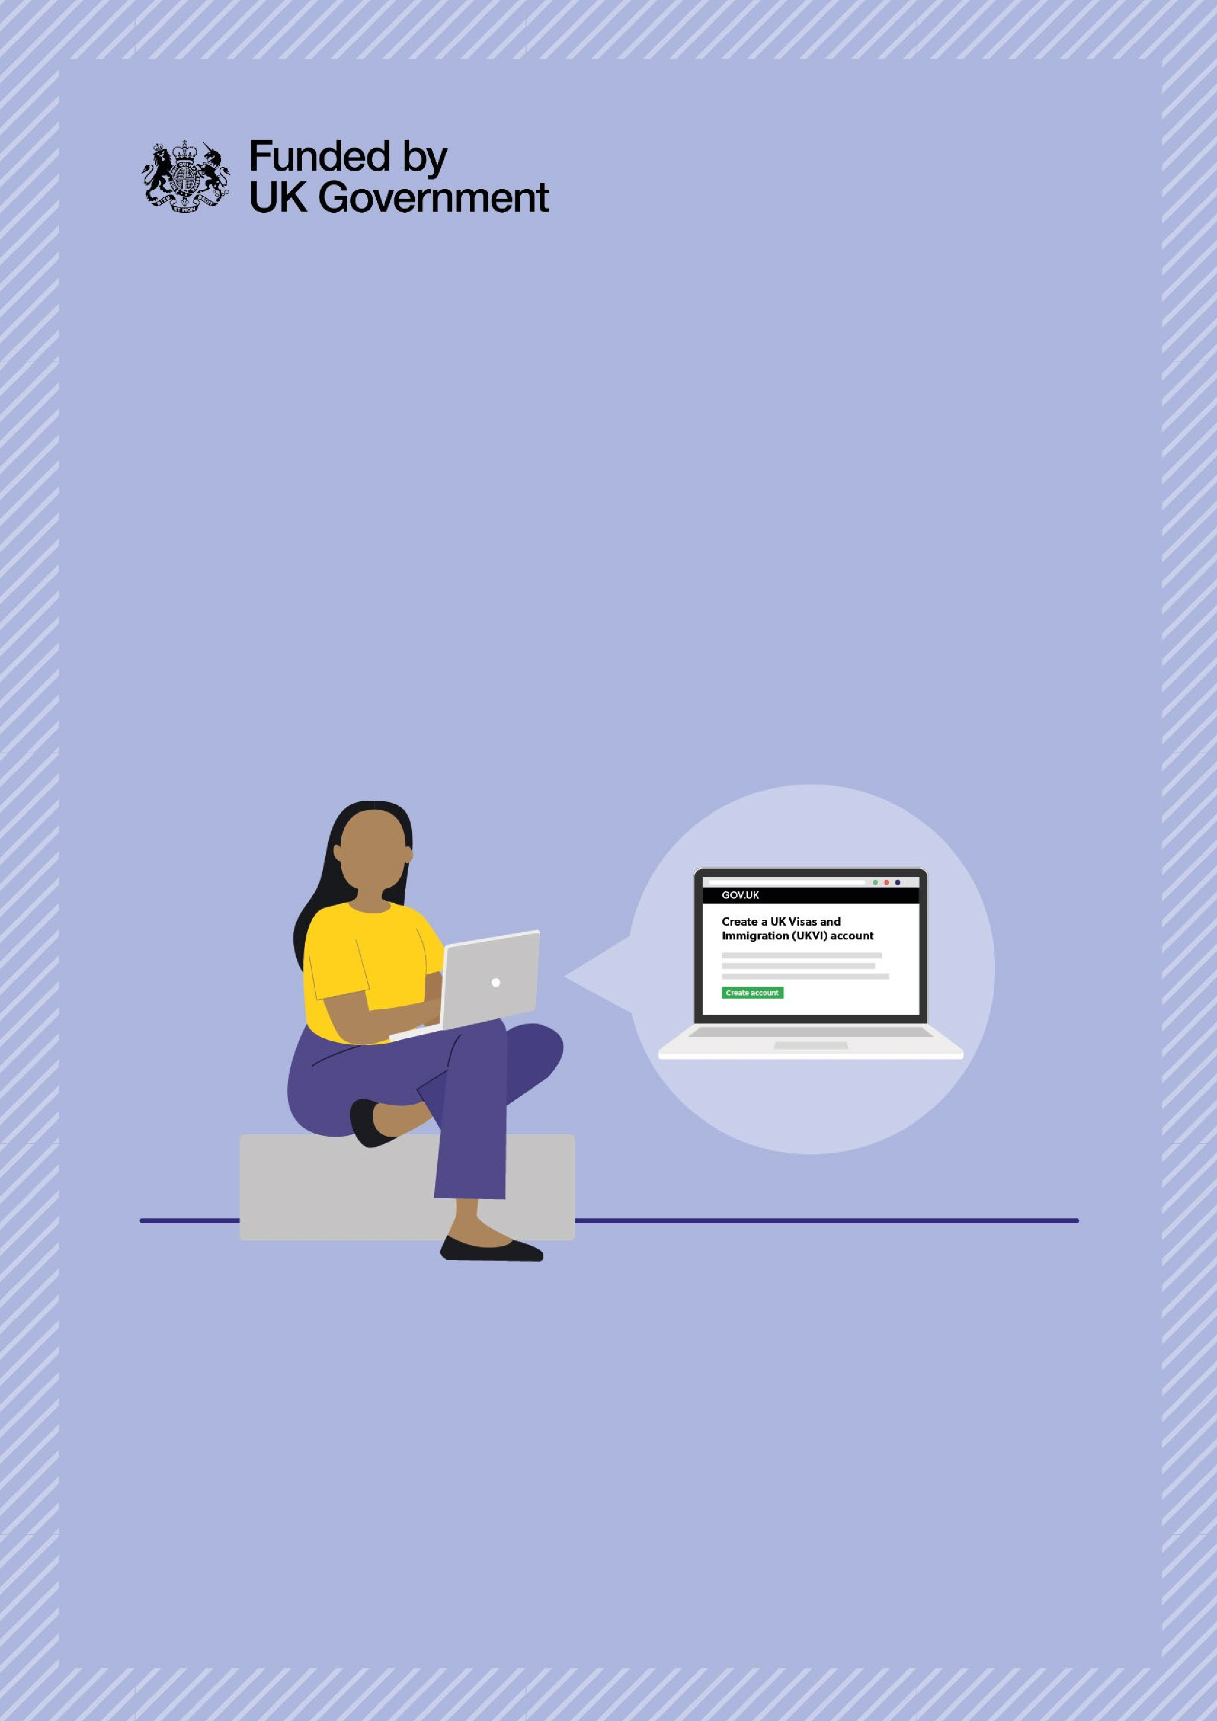
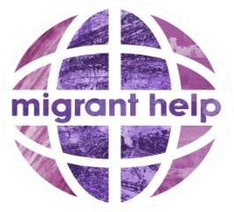

HELP IS AVAILABLE

If you need support
accessing your eVisa,

In your local area:
BURNLEY

For support with submitting your eVisa application, please contact us

to book an appointment via:

Migrant Help

evisa@migranthelpuk.org

Tel: 07483 170100

Please bring your BRP / BRC

and your passport, if available.

Fortnightly from
Thurs 26th June ‘25

Time:

10:00 – 13:00

Location: New Neighbours Together

St John’s Church Hall, off Ivy St,
West, Burnley, BB10 1TD

